**Computer Networks Lab week 3**

Name: Pranav R. Hegde | SRN: PES1UG19CS343 | Section: F

**HTTP authorization**

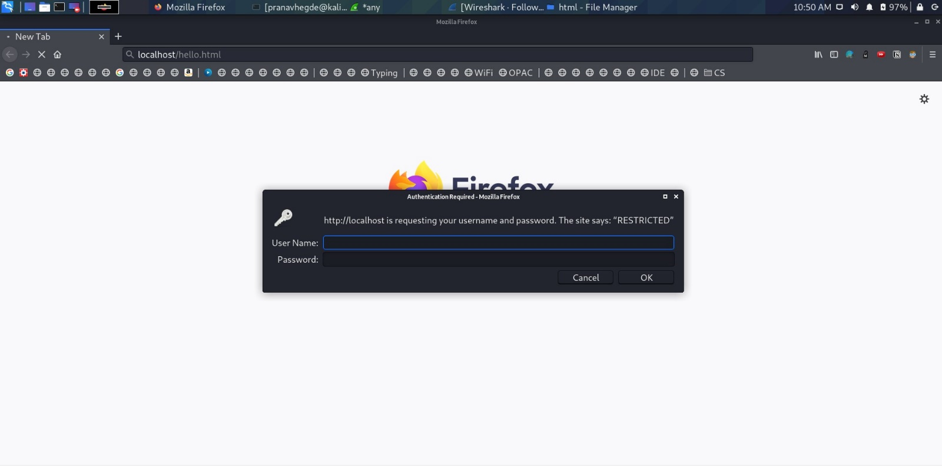

Accessing a restricted webpage locally hosted on apache2 server.

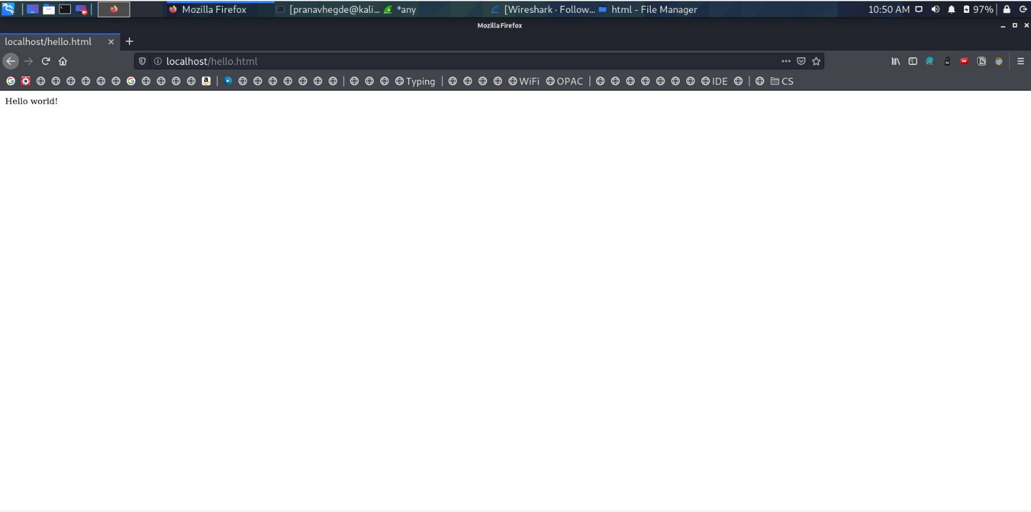

Website accessed after entering the credentials.

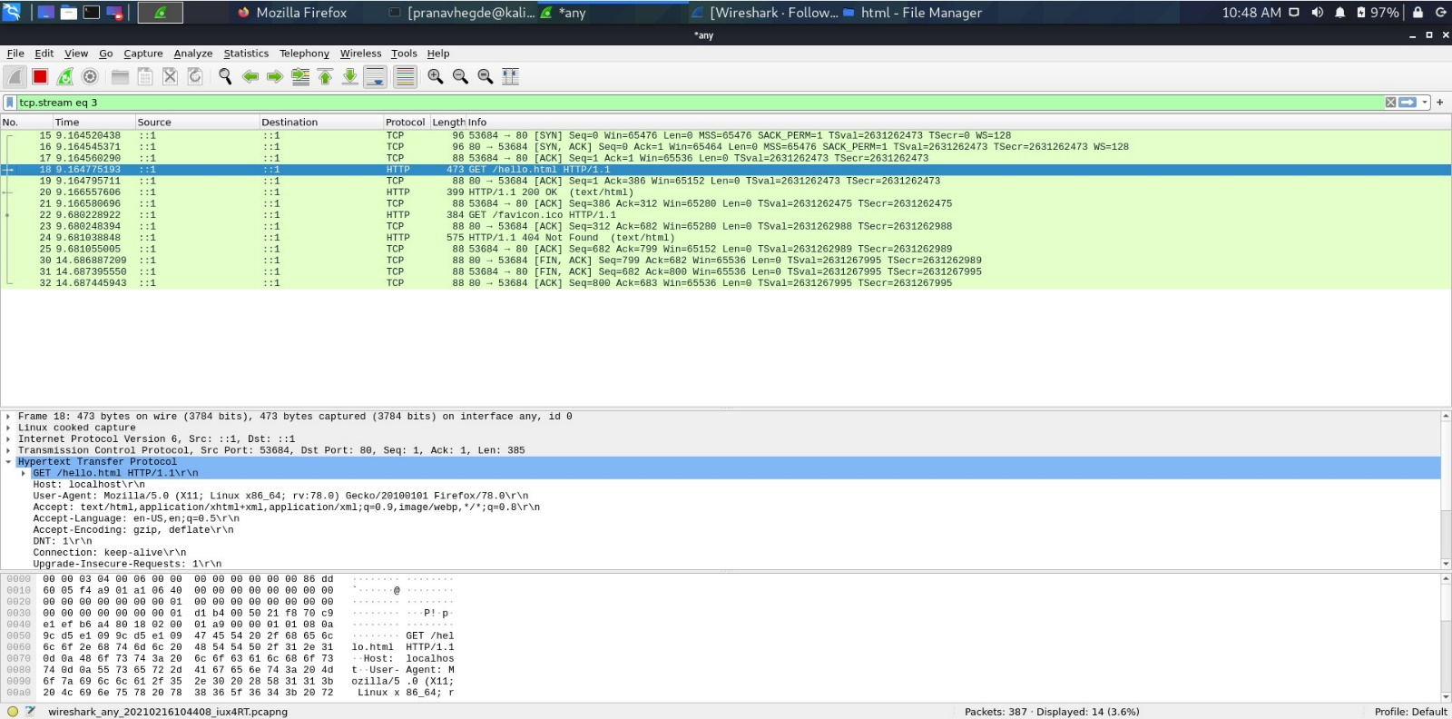

This is the image of the Wireshark HTTP PDU capture depicting the instances of accessing the above-mentioned webpage.

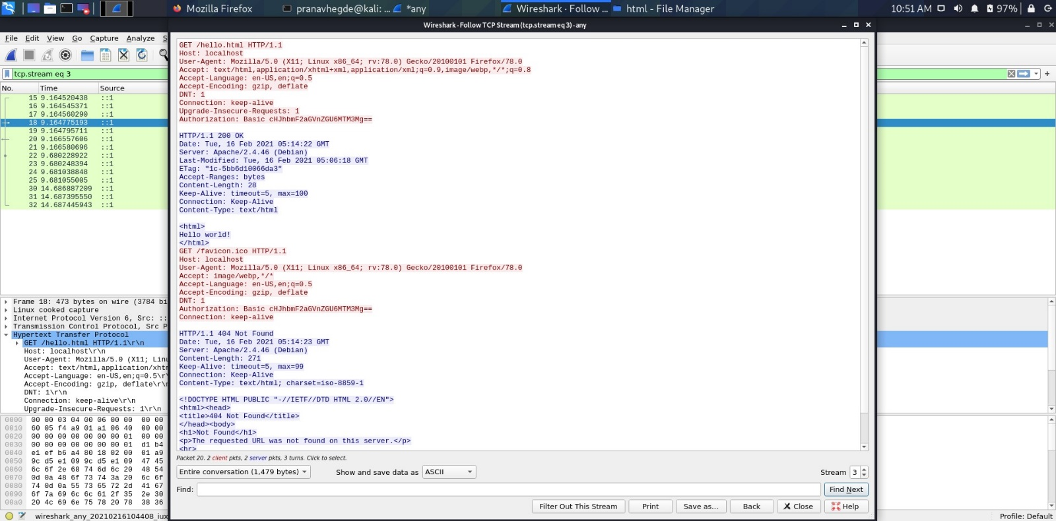

Restricted. This is the TCP stream follow up of Wireshark analysis of accessing the restricted webpage.

**Cookie setting**

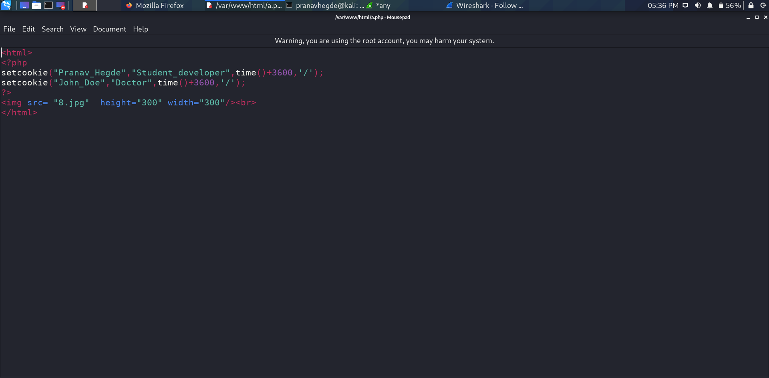

Setting cookies to the php webpage.

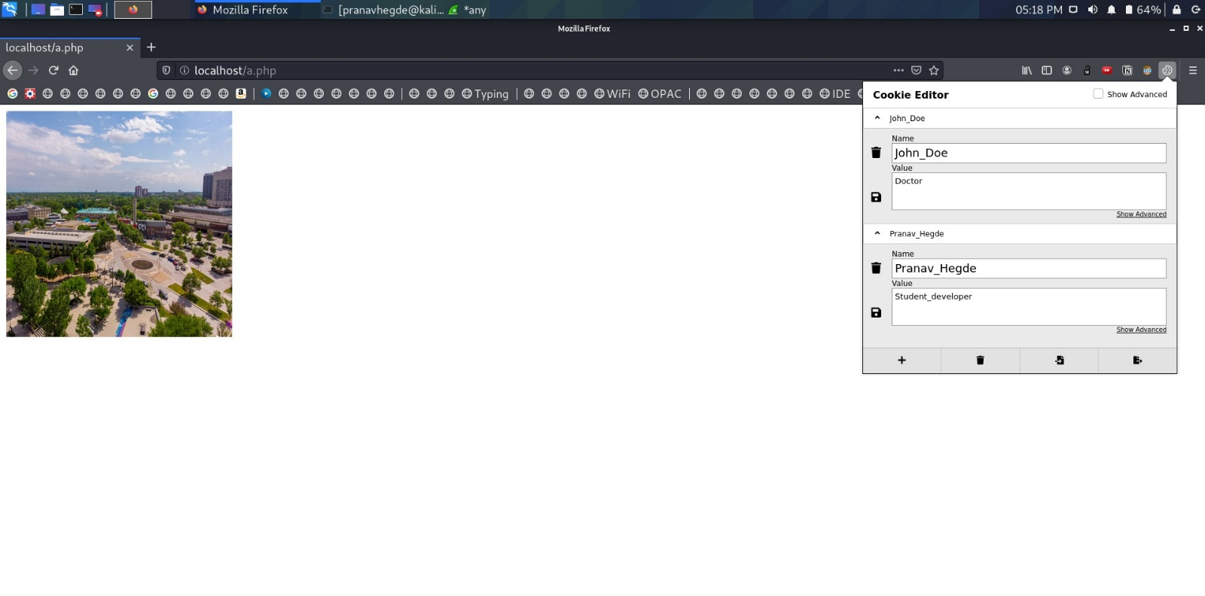

The a.php webpage accessed via authorization.

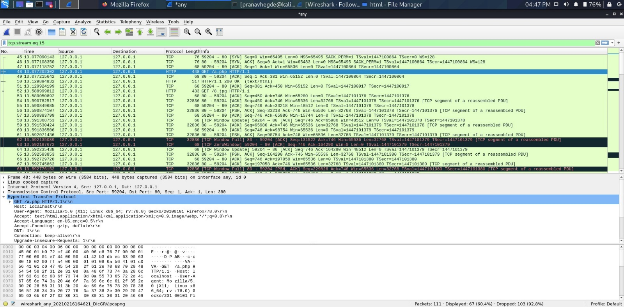

Wireshark HTTP capture of the a.php file.

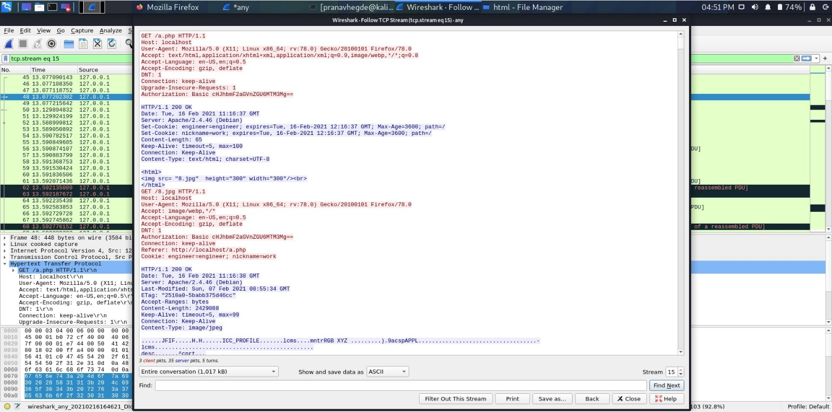

Following up TCP stream of the php page.

**Conditional get: If modified since** 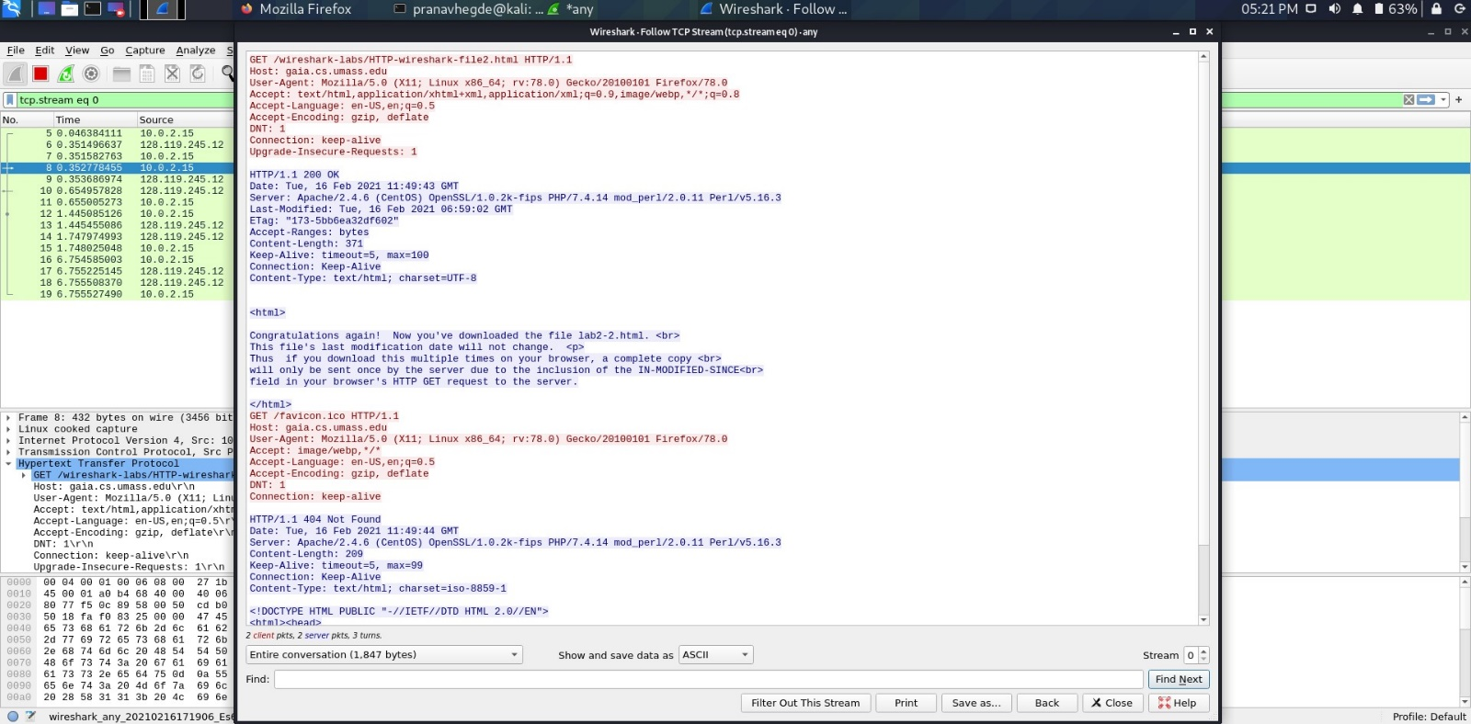

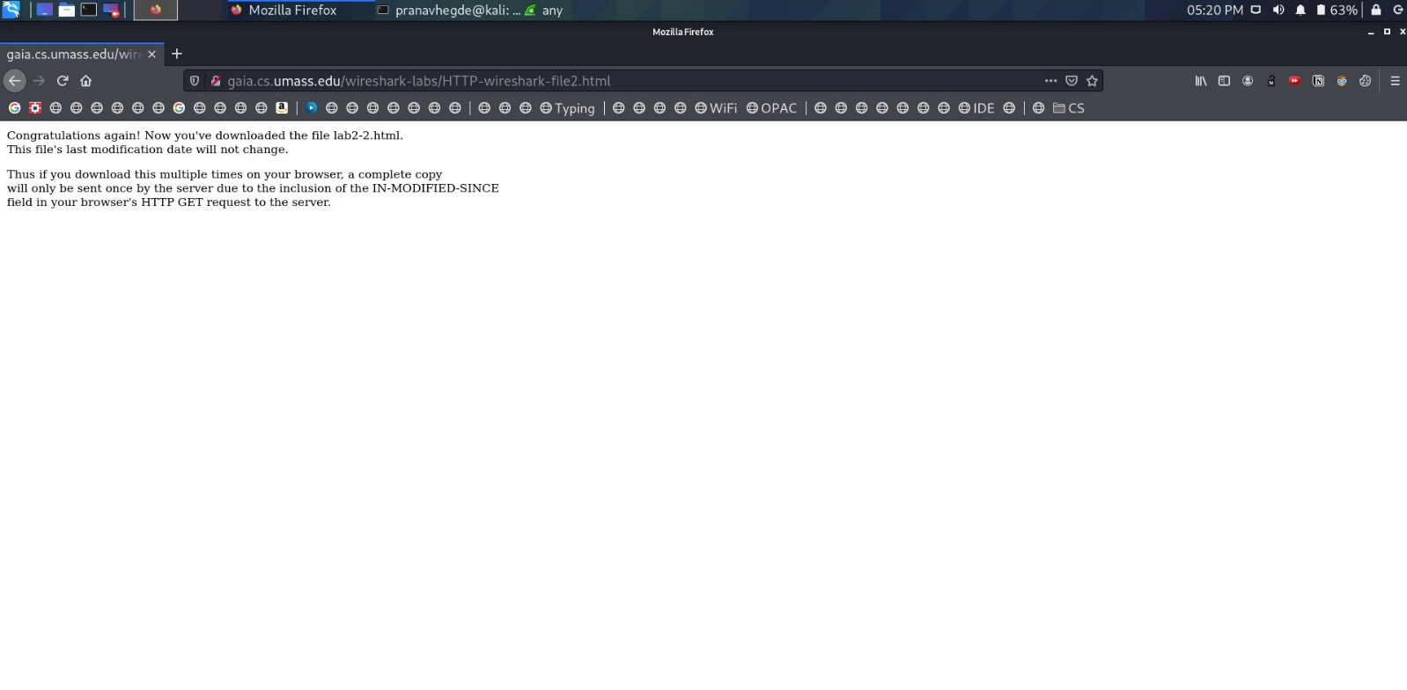

While accessing the webpage for the first time we do not see “If not modified” in the Wireshark TCP stream follow up.

However, when we access the webpage for the second time, we do see a “If not modified” in the Wireshark TCP stream follow up.

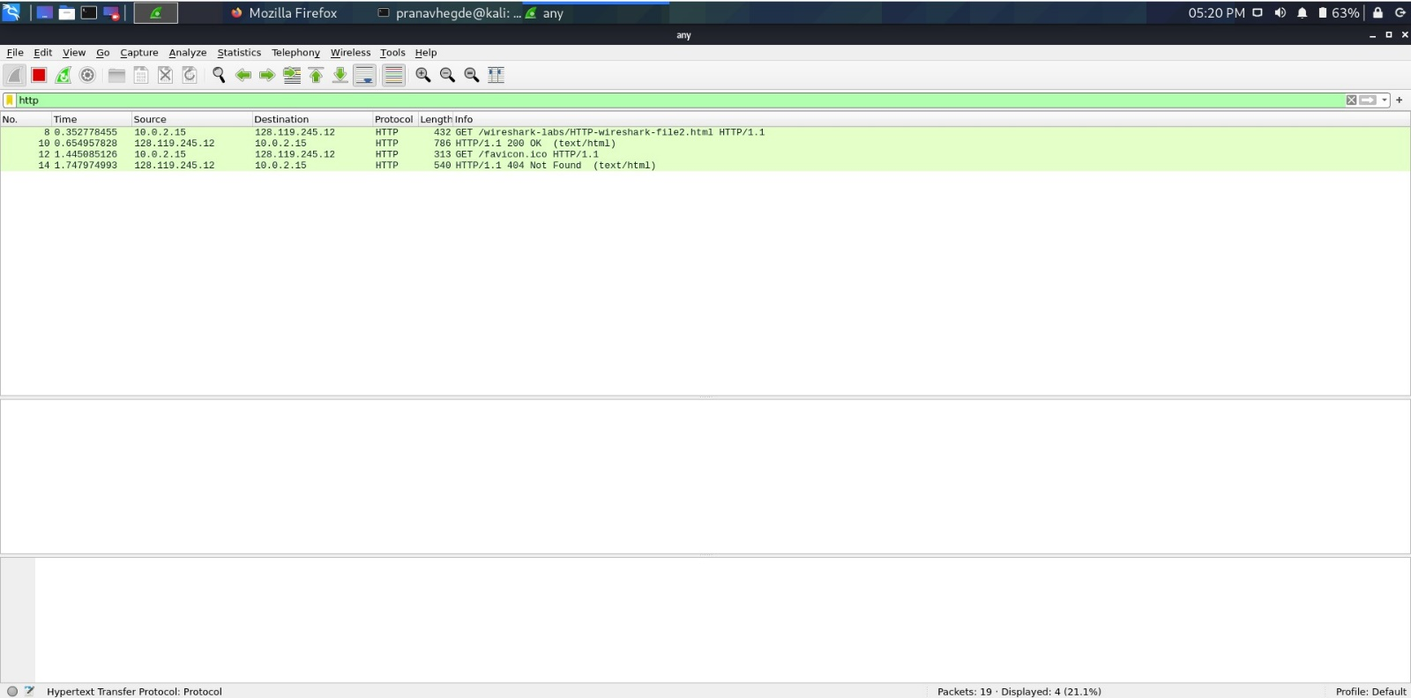

**Observations**

* While accessing the webpage for the first time we do not see “If not modified” in the Wireshark TCP stream follow up. However, when we access the webpage for the second time, we do see a “If not modified” in the Wireshark TCP stream follow up.
* The server does explicitly return the HTML contents of the file, while encrypting the authorization in the BASE64 encryption.
* The information that follows the “If modified since” header is the date and time the webpage was last modified.
* The server doesn’t send the data explicitly the second time. Instead sends the last modified data.

Decryption of the base64 encoding: pranavhegdehere